Bighorn Sheep

To survive the bitter winds and chilling temperatures of winter, bighorn sheep have developed thick, double-layered coats of hair. These rich, tan coats which grow anew late each summer, are shed in spring.
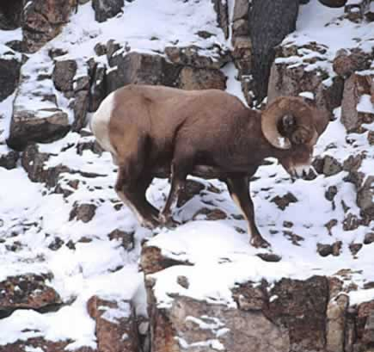
The digestive system of bighorn sheep is an unseen, but nonetheless essential, survival mechanism. In the initial phase of digestion, sheep benefit from teeth which grow throughout life, grinding down coarse, dry grasses and grit. A complex, four-part stomach allows sheep to gain important nutrients from hard, dry forage. Sheep are able to eat large amounts of forage rapidly, then retreat to cliffs or ledges to thoroughly rechew and digest their food, safe from predators.
Bighorn Sheep are well adapted to survive in the rugged terrain and harsh climate of the Rocky Mountains. Their keen eyesight, highly developed sense of smell, and sharp hearing enable bighorn to detect potential dangers at great distances. Specialized hooves, soft and flexible on the inside, aid sheep in precarious jumps and breath-taking climbs on sharp cliff faces, as they seek shelter and escape from predators in their rocky habitat.

Brahman Cattle
Brahmans have dark skin pigmentation, which filters the intense rays of the sun as well as keeps the breed free of cancer eye.
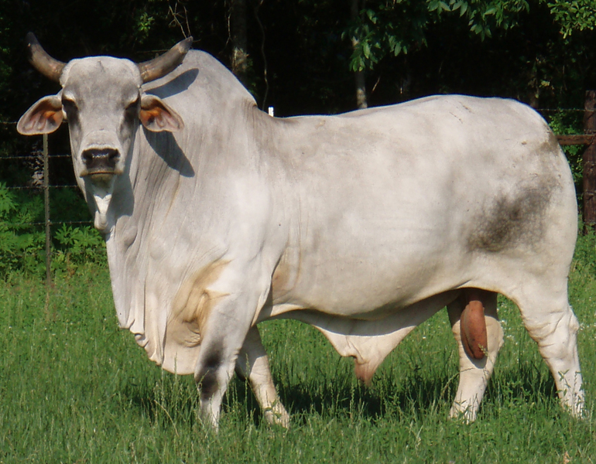
Other environmental adaptations which make the Brahman breed so well suited to so many areas of the country include the ability to utilize lower-quality feed, to travel longer distances for feed and water, and to resist insects and external parasites while withstanding vast climactic differences. They also have the ability to reproduce on a regular basis in a stressful environment.
Brahman cattle show no effect from extremely high temperatures. A factor which contributes to the Brahman's unique ability to withstand temperature extremes is a short, thick, glossy hair coat which reflects much of the sun's rays, allowing them to graze in midday sun without suffering. In severe winters, Brahmans grow a protective covering of long, coarse hair beneath which a dense, downy, fur-like undercoat can be found. A Univeristy of Missouri study found that BRAHMAN and European cattle thrive equally well at temperatures between 8 degrees F and 70 degrees F. Above 70 degrees F European cattle decline in appetite and milk production. Brahman cattle show little effect of temperatures up to and beyond 105 degrees F.
An abundance of loose skin, characteristic of the breed, also aids in its ability to withstand warm weather by increasing the body surface area exposed to cooling. In cold weather the skin is contracted, increasing the thickness of the hide and density of the hair, which aids in retaining body heat. A special feature of the Brahman breed is their ability over other breeds to sweat freely, which contributes greatly to their heat tolerance.
Pigs
Pigs have extremely rugged skeletons. These rugged skeletons support greater weight, in proportion to size, then any other farm animal. Breeders are continuously attempting at keeping a balance between fineness of bone and the amount of weight it can support.
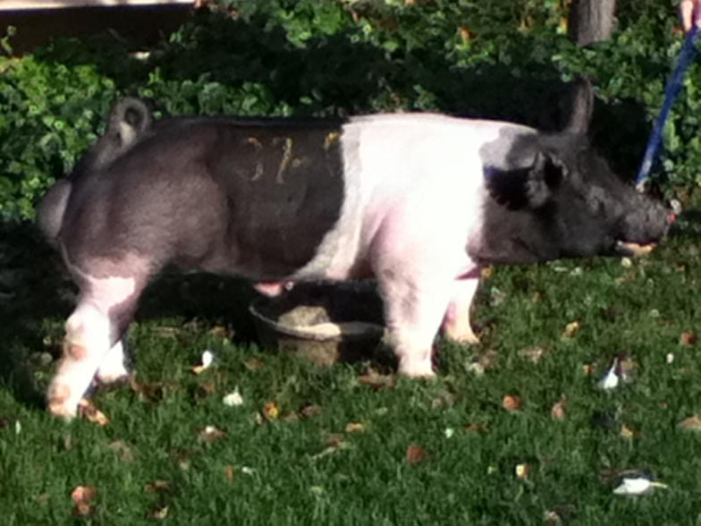
Breeders also watch the overall shape of the pig. Among the changes that can occur is the length of the body, which is usually related to the number of rib bones the pig contains.
Pigs are always leading with their noses – this nose is like none other. The pig nose, which can be short or long, ends in a floating disk of cartilage attached to muscles. This adaptation makes the pig nose not nearly as sensitive as the human nose. This becomes important because pigs lead with their noses. Because of this adaptation pigs were commonly used to hunt underground truffles. Truffles are highly prized delicacies from the family Fungosis.
The pig’s eye sight is said not to be as well adapted as other aspects of the body. Generally they have poorly developed muscles used for sharp focusing. Pigs have the inner eye structure called cones, in humans used for perception, but how pigs perceive perception is unknown. Domestic pigs are the only four-legged farm animals that do not have the inner-eye layer of light reflecting tissue called tapetum. This is likely because the early ancestors of the domestic pig were nocturnal. The position of the eyes on the sides of the head do provide for good lateral vision however.

Chickens

Our domestic chicken (Gallus domesticus) have developed specific physical features that allow better adaptation to their environment. Chicken feet reveal much about their ecology and behavior. Chickens have developed particularly strong feet and toes, an adaptation that allows them to scratch the ground, turn over leaves and rake up dirt to forage for insects and seeds. These strong feet, coupled with flexor tendons in their legs, also allow chickens to perch on roosts, a behavior that protects the birds from predators, particularly at night.
Birds have a highly efficient and lightweight digestive system that meets the needs of their high metabolism. The beak is adapted to the food habits of bird species. A wide, medium-length beak in chickens reflects their omnivorous diet. The small intestine is longer and more highly coiled than that of meat-eating birds.
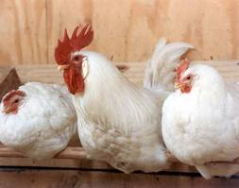
Commercial chickens grow quickly and have a very fast metabolic rate. As such, they require large amounts of oxygen. Birds' lungs are rigid, connected to nine membranous air sacs. With no diaphragm, birds rely on muscles between their ribs and sternum to expand and contract the chest cavities, drawing air into and out of the air sacs. A constant flow of fresh, oxygenated air across the lungs results in superior metabolic and respiratory efficiency. Chickens have hollow or pneumatic bones, an adaptation supporting flight by keeping body weight light.
Medullary bone is adapted to provide a source of calcium for egg-laying hens. A chicken hen supplies 47 percent of her body’s calcium to form one egg shell. In a commercial, egg-laying operation, hens cannot produce enough dietary calcium and must depend on calcium from medullary bone. Roughly 10 to 14 days before an egg is laid, under the influence of estrogen, medullary bone is formed in the marrow cavities of certain bones – including the tibia, femur and scapula. The breakdown of this bone supplies additional calcium to support proper egg shell development. Absent this additional calcium, egg shells would be weak and thin.
Horses
Domestic horses are found in a variety of sizes and due to selective breeding, they have developed unnatural adaptations. A breed such as the Shire Horse, for instance, was bred to be large; selective breeding has caused its joints and muscles to adapt to take on the strains of this increased size. Shetland Ponies that developed on exposed islands north of Scotland adapted to have thick, shaggy coats that protected them against the elements. Certain kinds of horses have also been bred to adapt and perform specific tasks. Large and heavily-muscled horses do pack work while slender horses, such as Arabians, are excellent for speed and endurance.
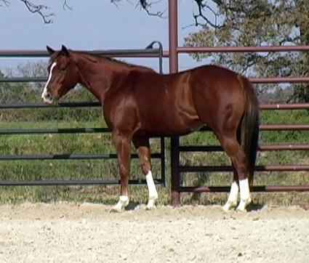
No matter what the breed, all horses share common adaptations. As a defense against the irritation caused by insects biting around their hindquarters, all horses swish their tails -- which they come by naturally -- to deter and swat at insects. When horses walk on rough, rocky ground or on roadways, their hooves wear down. Consequently, hooves grow at a rapid rate of about 1/4 inch per month. Horses' large bodies and the overall physical strain they endure naturally requires that they have a powerful heart. An average sized horse has a heart that weighs approximately 9 lbs.; the size of the heart differs in smaller and larger breeds.
Due to their large bodies and relatively slender legs, standing up from a laying down position can be taxing for a horse. They have adapted by sleeping mainly while standing up and only rarely lay down. Horses prefer to live naturally in herds that generally have a social dominance structure. In the wild and in some domestic herds, a dominant male will have a harem of several females it will breed with and protect. This behavior ensures that the strongest and fittest males pass on their genes. Within the herd, social bonds are also forged and maintained when the horses groom one another.
Like many large herbivores, horses have adapted for predator defense. Their eyes are located on the sides of their heads, which enables them to watch for predators and see nearly 360 degrees around. A keen sense of smell also helps the horse be alert for possible danger as the horse will pick up unusual scents in the air easily and be warned of an approaching predator or threat.
Pheasants
Common pheasants are opportunist feeders, eating whatever they happen to find while walking around. To avoid predators on the ground, they roost in trees at night. The male’s call sounds like “keheen,” and can be heard throughout the spring. The female’s dull colors are a great camouflage compared to the male’s colorful feathers, easily seen on open farmland. The male’s bright colors also attract females so he can form a harem during the breeding season. The pheasant is a very fast runner, carrying the tail at a 45-degree angle. Besides being fast, they can also flap and glide for long distances, and when startled, a pheasant will burst straight into the air. Pheasants have been observed landing in water and swimming to shore, but they are unable to take off from the water. The two horns on the top of the head are raised when the pheasant is alarmed, and for its large size, it is able to hide in small patches of grass fairly well.
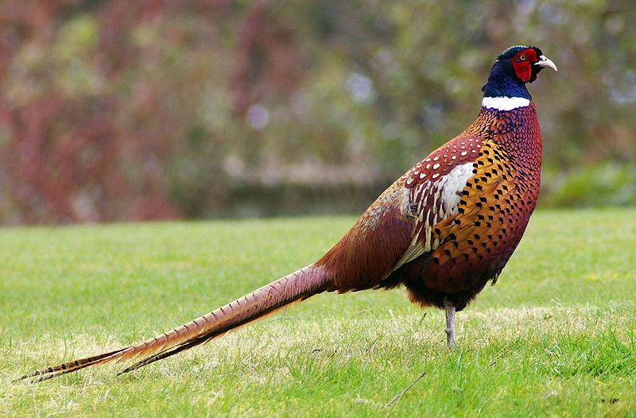

Deer
Deer are successful herbivorous mammals that originally spread out from Europe to all other continents, except Australasia and Antarctica. There are many different species of deer that cannot inter-breed, each with their own specialized adaptations. Deer species often have similar food sources, but adaptations for predator evasion tend to be divergent.
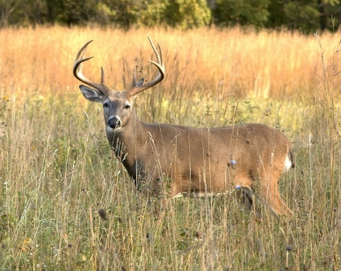
Males in all species except for the Chinese water deer have antlers. The only female species to have antlers are reindeer or caribou. Antlers are grown in spring preparation for the mating season and are considered highly exaggerated secondary sexual traits. They are covered in a layer of "velvet" during formation, which is highly vascular tissue. This supplies oxygen to the structure growing beneath. Before the mating season, calcification results in the antlers becoming hard bone.
Deer are commonly brown or tan, with some species displaying piebald coloring. Piebald deer are brown with white spots or patterns, such as the chital deer found in wooded parts of Asia. Their coloring camouflages them with their environment so that it is harder for predators to see them. When alerted, some deer might freeze and use their camouflage to evade detection. If discovered, species that are adapted to living in woods and thickets may flee in rapid leaps.
Like many predated animals, deer have eyes located on the side of their heads. This allows them to have a large field of vision so that approaching predators can be more easily spotted. In addition, large maneuverable ears give deer excellent hearing, and allow them to focus in on quiet noises in one direction, helping them to evade predators.

