Name:_____________________________________________________Period:________
DNA Test Review

DNA/STRUCTURE
- Where in the cell is DNA mainly found?

- What makes organisms different from each other?

- Sally has her DNA sequenced and it is found that 40% of her DNA is made up of the nitrogen base adenine. What percent of her DNA would you expect to be made of thymine?

- The building blocks that make up DNA are:

- What are the building blocks of DNA called? (Hint: The monomer of nucleic acids is…)

Use the diagram of a DNA molecule below to answer questions 5-7.
C
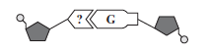
5. The structure labeled ? is a:

6. The Dark shaded structure is:

7. What type of bond forms between the G and the ? in the diagram?

8. If you were to put cells in salt water, what would happen to them?

9. If the sequence of nitrogen bases in 1 strand of the DNA is CGACTT, what is the sequence of bases on the opposite strand of DNA?

10. What is a DNA molecule in the shape of?

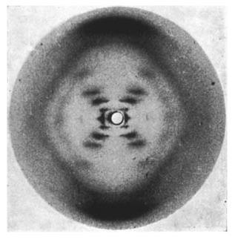
DNA/HISTORY

11. What is Chargaff’s Rule?

Use image for questions 12-13

12. This is the first image of DNA. Who is responsible for taking this image?

13. What does this image show us about DNA?

DNA/REPLICATION
14. Which process ONLY involves DNA?
  - Translation
  - Cellular Respiration
  - Active Transport
  - Replication
15. What does each enzyme do in DNA Replication?
1.
2.
3.
4.

16. What is DNA Replication?

PROTEIN SYNTHESIS

17. What is the name for the nucleic acid that contains the sugar ribose and the nitrogen base uracil?

18. Which carries the DNA code to the ribosomes?

19. Where in the cell are proteins built using the mRNA code?

20. The following DNA strand is the code for making insulin in the body. Identify the mRNA strand.
TAC/CCG/TAT/AGG

21. What is the name for the process of making proteins (chaining together amino acids) from the RNA code?

22. What is the name for the molecule that carries amino acids to the ribosome and helps chain them together?

23. Why is the order of the molecules labeled C, G, A, and T important?

24. Put the following in order of when they are used in protein synthesis: tRNA, mRNA, Ribosome, DNA, Protein, Amino Acid, Amino Acid Chain.

25. Use the following Amino Acid chart to build the protein that would be coded for with this DNA sequence.
TAC/GGC/CTA/ACT

