Name_____________________________________________________________ Period________________
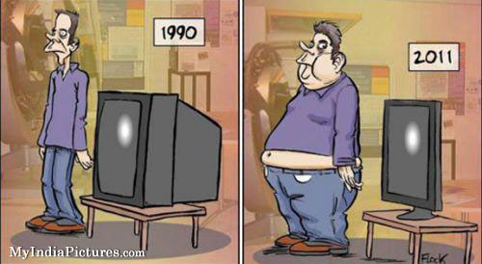
Evidences for Evolution
Go to the following: http://www.zo.utexas.edu/faculty/sjasper/images/mimicry.jpg
- What is mimicry:

- Why would some of the butterflies be selected to look like butterflies that are poisonous?

Rock Pocket Mice
http://www.hhmi.org/biointeractive/pocket-mouse-film-quiz
- Define “mutation”

- What was the selective pressure in these mice (what caused some of them to live and some to die?)

- What color of mice would you expect to find on the lava rock?

- How is it possible that the mutation that caused dark fur was able to turn an entire population black in such a short amount of time (approximately 1,000 years)?

- “While mutation is random, natural selection is not.” In your own words, explain how this is possible.

- True or False: “The same mutation could be advantageous in some environments but deleterious in others.” Justify your answer in one or two sentences
(Stop at 8:00)

Go to: http://www.zoology.ubc.ca/~bio336/Bio336/Lectures/Lecture5/Overheads.html
- What is a homologous structure?

- How does the homologous structures of Tetrapods show evolution from a common ancestor a long time ago?
Lactase and Lactose – Got Lactase?
http://www.hhmi.org/biointeractive/lactase-film-quiz
Evolution can also happen from cultural changes.

- What two monosaccharides (simple sugars) are formed when the lactase enzyme hydrolyzes lactose?

- Mammals can digest milk sugar when they are young and their only food source is mother’s milk. All mammals except humans STOP producing lactase as they age. Humans are an exception to the rule. How many humans are Lactase Persistent (Still able to produce Lactase)?

- What cultural change in populations caused digesting milk to be advantageous?

- True or False. “Human evolution ended 200,000 years ago when humans (Homo sapiens sapiens) became a distinct species.” Justify your answer in one or two sentences.
Stop at 9:00

Three Spined Stickleback Fish
https://www.hhmi.org/biointeractive/stickleback-film-quiz
Stickleback fish used to live in the oceans (salt water). Now, they are fresh water fish. Name 5 ways their body look different from their ancestors who lived in the sea.
Change in body | Benefit in New Environment
1.

2.

3.

4.

5.

Changes in form are due to changes in __________________. However, in these fish they noticed the genes that coded for a pelvis were the same in both type of fish. So why did some fish have a pelvis and others not?

Can evolution repeat itself? How do we know?

http://www.pbs.org/wgbh/evolution/educators/teachstuds/svideos.html
#1 Isn’t Evolution Just a theory?

#2 Who Was Charles Darwin?

#3 How Do We Know Evolution Happens?

#4 How Does Evolution Really Work?

#5 Did Humans Evolve?

#6 Why Does Evolution Matter Now?

#7 Why is Evolution Controversial Anyway?

Write a Paragraph summarizing what you learned today, key concepts or questions you may still have:

