Dahlias
(Figaro Series)

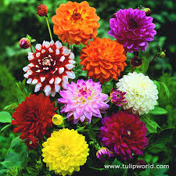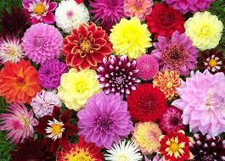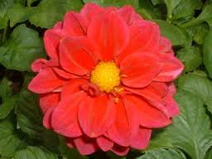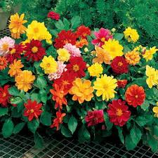

Brief Summary  Dahlias are a beautiful flower which many people love. There are many different colors and types of dahlias. The type of dahlia we have is the Figaro Series. This flower can help in any flower arrangement and they are so pretty! You definitely want to add these flowers to your garden!  Where to Buy  The Best place to buy dahlia seeds or starters is Ball Horticulture. You can buy them online at ballhort.com. You can also buy dahlias at most greenhouses in your area. There are many places that sell dahlias.  Propagation  You can propagate dahlias through growing seeds, plant cuttings, or dividing the plant roots that you grew the year before.  The Propagation technique we used was the seed technique. All you do is fill your 1801 with a soilless media mix, then moisten the soil, make a small hole about a quarter of an inch deep, put the seed in and cover it up. It is a really great procedure to help your dahlias grow.  Growing Procedures  There are many growing procedures for growing Dahlias. Some of the growing procedures include: Planting the seeds in a greenhouse, planting the sprouts in an outside garden, watering the dahlias, making sure there are no weeds by your dahlias that take up all of the water and having good pest management. These are all good procedures to allow your dahlias to grow the best that they can! Other growing procedures include pinching, disbudding, growth regulators, spacing. To disbud your dahlias you need to remove the two side buds at the end of the branch and this will really help your dahlias bloom.  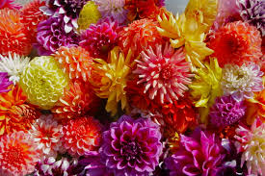 | Temperature  Plant your dahlias in a place that gets at least six hours of sunlight a day. Most dahlias like a warmer climate. If you don’t keep the dahlias at the right temperature then there is a chance that you may kill the plants. Make sure you keep your dahlias at the right temperature!  Photoperiod  The photoperiod for dahlias would be 11-12 hours a day. If you do a shorter time than that then it will shoot the growth of the dahlias, which then eventually causes the plant to die, make sure your dahlias receive the correct amount of sunlight.  Fertility  Make sure you use fertilizer when planting your Fertilize them with peterson 202020. A good soil type with a p.H of 6.0-6.5. After the sprouts emerge you can sprinkle 5 - 10 - 10 or 2 - 12 - 12 soil which helps them grow.  Pest Management  The most popular insect that attacks dahlias are aphids. They spread disease which causes them to kill the dahlias. Other pests include the Corn Earworm, Blister Beetles, and the European Corn Borer which can all be killed with Carbaryl. You can kill spider mites with dicofol. Follow the directions on the bottle and use caution. Do not use too much pesticide or else it will harm the plant.  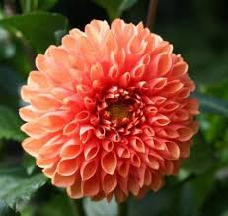

References and Citations

"Dahlias." Old Farmer's Almanac. Web. 13 Apr. 2016.

"Dahlias for the Home Landscape | NC State University." Dahlias for the Home Landscape | NC State University. Web. 13 Apr. 2016.

Hammer, P. Allen. "Dahlia Photoperiod Control." E.gro. Fine, 21 Jan. 2014. Web.

Runkle, Erik. "Controlling Photoperiod." Crop Cultivation. Oct. 2002. Web.

University, Utah State. "Growing Dahlias." USU Extension. Web.

http://www.almanac.com/plant/dahlias

http://www.flor.hrt.msu.edu/assets/Uploads/Controllingphotoperiod.pdf

http://e-gro.org/14_webinars/Dalhia%20Photoperiod.pdf
http://content.ces.ncsu.edu/dahlias-for-the-home-landscape
http://extension.usu.edu/boxelder/files/uploads/Dahlias.pdf

