Name:_______________________________________Date:____________Per:_______
Genetics Test Review

- Who was the first known person to determine traits of offspring are not just a mix of the traits of the parents? He is considered the father of genetics.
Gregor Mendel

- In fruit flies, the gene for red eyes (R) is dominant and the gene for white eyes (r) is recessive. What are the possible combinations of genes in the offspring of two red-eyed heterozygous flies (Rr)? Show your work.
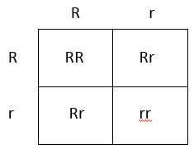 RR, Rr, rr

- In certain breeds of dogs, deafness is due to a recessive allele (d) of a particular gene, and normal hearing is due to its dominant allele (D). What percentage of the offspring of 2 normal heterozygous (Dd) dogs would be expected to have normal hearing? Show your work!
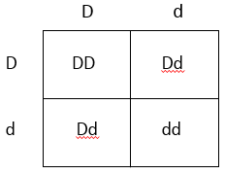 75% (3/4)

- What type of allele is represented by a lower case letter, dominant or recessive?

Recessive

- In human blood types, when someone has the allele IA for Type A blood AND the allele IB for Type B blood, it results in Type AB blood. What type of inheritance patter determines blood type in human?
  - Complete dominance c. Co-dominance
  - Incomplete dominance d. Multiple Allele

Define the following:
- Phenotype: Physical representation of a gene (Blonde/Brown, Normal/Blind, Red/White)
- Genotype: The genetic makeup of an organism represented by letters we assign (AA, Aa, aa)
- Co-Dominance: Both traits show
- Sex Linked Trait: Genes that on the sex chromosomes
- Allele: a form of a gene located on the chromosomes
- Chromosome: tightly wound DNA

- What determines the traits of an organism? DNA

- A grey haired rabbit (GG) and a grey haired rabbit (Gg) have what in common?
  - genotype c. recessive
  - phenotype d. eye color

- A variety of fern plant has 460 chromosomes in its diploid cells. How many chromosomes does it have in its gametes? 230

- Botanists cross a heterozygous (Pp) plant having purple flowers with a homozygous (pp) plant having white flowers. About what percentage of the offspring will have purple flowers? Show your work!

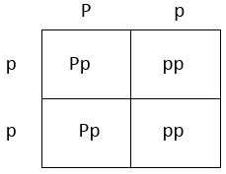

50%

- Homologous chromosomes separate during meiosis I.
a. True b. False

The following section focuses on sickle cell anemia.
Use the diagram below to answer the next four multiple-choice questions.

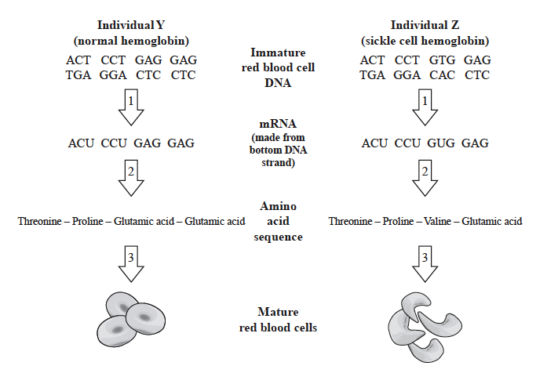

- Which of the following statements best describes why the change in only one DNA base of the hemoglobin gene results in a different protein product of the gene?
  - The change alters the amino acid sequence of the protein.
  - The change causes the blood cells to divide in an uncontrolled way.
  - The change creates a second strand of mRNA for each RNA molecule.
  - The change prevents mRNA from being made.

- Which of the following cell structures carries out the process represented by the arrows labeled “2” in the diagrams?
  - Mitochondrion c. Ribosome
  - Nucleus d. Vacuole
- Which of the following statements best summarizes a change that is represented by the arrows labeled “3” in the diagrams?
  - A chain of amino acids forms a protein in each cell.
  - A nucleus is formed in each cell.
  - Each cell divides to form two daughter cells.
  - Proteins are transported through the plasma membrane of each cell.

- Which of the following statements best compares individual Y and individual Z in terms of genotype and phenotype?
  - The individuals have different genotypes and different phenotypes.
  - The individuals have different genotypes but the same phenotype.
  - The individuals have the same genotype and the same phenotype.
  - The individuals have the same genotype but different phenotypes.
Answer the next two questions from the data in the following pedigree.

1 2

3 4 5 6

- How would the shaded in person’s trait be described?
  - Dominant. c. Recessive
  - Sex-linked d. Co-dominance

- What term describes individuals #1 and #2?
  - Co-dominant d. Carrier
  - Unknowns c. Recessive

The following pedigree chart shows sex-linked inheritance of color blindness for three generations of a family. Color blindness is recessive and represented by a shaded shape. Males are represented by squares, females are represented by circles. Review the pedigree chart. Answer the following question.

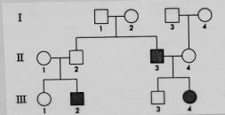

- What is the genotype of Individual #4 of the second generation?
  - X^{C}X^{c} c. X^{C}Y
  - X^{C}X^{C} d. X^{c}Y

Use the karyotypes below to answer the next two questions:
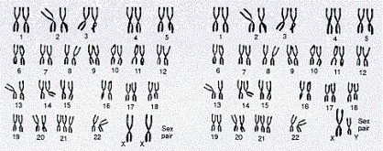
- Which pair of homologous chromosomes are abnormal or carries a genetic mutation?
  - 21st pair d. 13th pair
  - 23rd pair c. 18th pair

- The karyotypes above are of:
  - 2 females c. 1 female, 1 male
  - 2 males d. You can’t tell from the information
22. The female individual has what disorder?
a. Trisomy 21 (Downs Syndrome) b. Turner’s Syndrome c. Kleinfelters

23. In pigs, color is determined by co-dominance. If a red pig breeds with a black pig, what color will their offspring be?
a. red c. both red and black
b. black d. really dark red

24. Why are blood types considered an example of a multiple allele trait?
  - Blood type O can be donated to anyone, AB cannot
  - Surface proteins A and B will both show up when present
  - There are four types of blood, not two
  - There are three possible alleles for blood type

25. A particular breed of cattle can have long horns, medium horns, or short horns. The trait is incompletely dominant. A rancher has a customer that wants to buy some medium horn cattle. The rancher needs to know which parents he should breed together to get the most medium horned cattle as offspring. You suggest to him that he should mate…
  - two medium horned cattle
  - 1 long horn with 1 short horn.
  - 1 long horn with 1 medium horn.
  - 1 short horn with 1 medium horn.

26. The creeper syndrome in chickens is due to a recessive condition that results in the severe shortening of legs. A chicken producer mates a rooster (Cc) to hens that are carrying the creeper gene also (Cc). What are the expected phenotypic ratios of the offspring of each hen. Show your work!
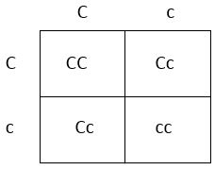

Phenotypic ratio: 3:1
(3 Normal, one creeper syndrome)

Genotypic ratio: 1:2:1
(1 Homozygous dominant CC, 2 Heterozygous Cc, 1 Homozygous
Recessive cc)

27. Hemophilia is a sex-linked recessive gene. If a male who has hemophilia has children with a woman who is heterozygous for the trait what percentage of the male offspring with have hemophilia? Show your work!
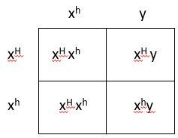

50% of the male offspring will have hemophilia

28. A local hospital thinks they might have mixed up two newborns. Little baby Al has A blood, and little baby Sal has O blood type. Which baby belongs to parents Kim and Tim who have blood types AB and B? Show your work!!

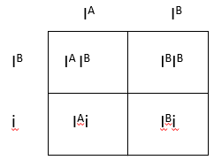

It would not be possible for that combination of parents to have a child with O
blood type. Baby Al belongs to those parents.

29. If a male who has the genotype AaBB is crossed with a female that is AAbb, what is the probability that they will have children that are recessive for both traits? Show your work!!

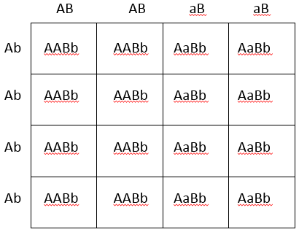

0%

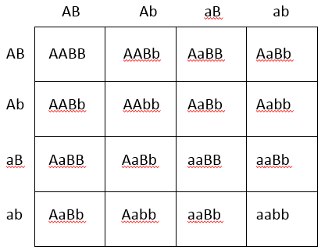
30. What is the phenotypic ratio of a dihybrid cross?
a. 3:1
b. 1:2:1
c. 9:3:3:1
d. 1:1:1:1

When you cross AaBb with AaBb you get:
Both dominant traits showing: 9
Trait A dominant shows, b recessive shows: 3
Trait a recessive shows, B dominant shows: 3
Both recessive traits showing: 1

