Scenario #1
In England, there are white and black peppered moths. They live on lichens and tree bark that are light in color, allowing the white moths to be camouflaged from insect-eating birds. Chart A shows the change in the coloration of the moth population over time. Chart B shows pollution levels in England over time.
Number of Individuals in Population
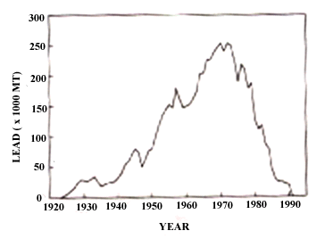
Year
Amount of Air Pollution

Scenario #2
A scientist is studying the bacteria E.coli in his laboratory (E.coli are single-celled and reproduce asexually). He begins growing his bacteria using a petri dish that he places in a warm environment. On the third day he changes his mind about the study and decides to kill off his E.coli by adding an antibiotic to the dish. When something strange happens he decides to chart the bacteria’s growth as shown below:

Day 6
Day 5
Day 4
Day 3
Day 2
Day 1

Scenario #3
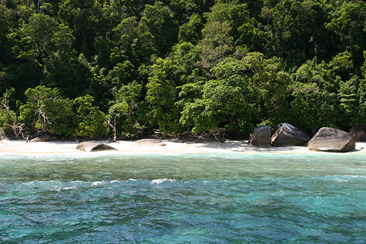
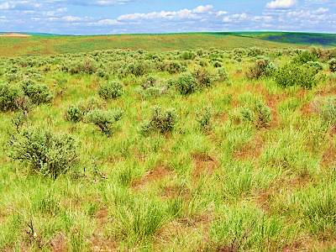
On a small group of islands off the coast of South America you can find a type of bird called a finch. Each island has its own population of finches and its own variety of food resources. One day you come across two of these islands as shown below. Both islands have finches with small beaks and large beaks. West Island has an environment better suited for shrubs and grasses that produce small seeds (popcorn kernels); East Island has a lot of trees that produce larger seeds and nuts with tough shells (marbles). Using the small and large binder clips (small and large beaks) determine which beak size is best for each island by attempting to transfer the kernels/marbles from the tray to the cups provided.
East Island
West Island
Use the scenario information sheets to answer the questions in each of the three sections.
Name:_____________________________________ Period:_________________
Scenario #1: Peppered Moths
Exploring Natural Selection
- What effect does pollution have on the population of white peppered moths?

What effect does pollution have on the population of black peppered moths?

- Describe how air pollution might be affecting the moths’ habitat (hint: look at the pictures of the moths).

- What is your hypothesis for how the peppered moth population is changing?

Scenario #2: E.coli
- If E.coli reproduce asexually, is there genetic variation in the bacteria from Day 2?

How could some of the bacteria have survived the antibiotic?

Are the bacteria that survived a whole new species from the bacteria that died? Explain your thinking.
Scenario #3: Finches
- Which beak is better suited for the small seeds of West Island?

Which beak is better suited for the large nuts of East Island?

- Now that you know which beaks are advantageous for each island, which type of finch would you expect to be more common on each island 50 years from now?

Explain your reasoning:

