Name:_______________________________________________Date:_______________Period:_____________
Cells & Energy Test Review
Section 1: Cell Theory & Cell Organelle Functions
- What are the 3 parts of the cell theory?
  - Cells are the basic unit of life
  - All living organisms are made of cells
  - Cells come from other cells
- What invention led to the discovery of cells? (How do we see really really small stuff?)
Microscope
Describe the function of each cell part in picture below:
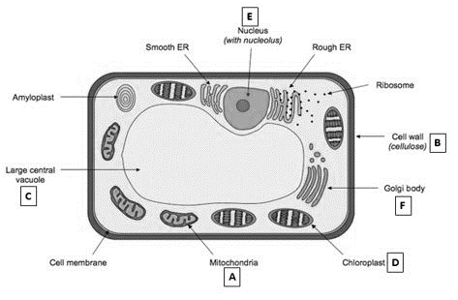
Functions:
- Nucleus: Holds & protects DNA
- Vacuole: Stores water and nutrients
- Ribosome: Makes amino acid chains (proteins)
- Golgi Body: Packages & distributes proteins
- Endoplasmic Reticulum: Folds proteins. Where
ribosomes are located.
- Chloroplast: Makes sugar using the sun’s energy
- Mitochondria: Produces ATP energy using glucose
& oxygen
- Cell Wall: Provides structure to plant cells
- Cell Membrane: Controls what goes in and out of the cell
- Is the cell above PROKARYOTIC or EUKARYOTIC? How do you know??

Eukaryotic. Eukaryotic cells have a nucleus. Prokaryotic cells (like bacteria) do not have a nucleus.

- Is the cell above a PLANT cell or an ANIMAL cell? How do you know??

Plant cell. It has chloroplasts, a cell wall and a large central vacuole. Animal cells do not have chloroplasts or a cell wall and they have smaller vacuoles.

- Which cell parts are used for making proteins (3 organelles)? Rough Endoplasmic Reticulum, Ribosomes, Golgi Body

- Which cell parts are used for producing and using energy (2 organelles)? Chloroplasts (produce sugar using the sun’s energy), and mitochondria (produce ATP energy from glucose and oxygen)

- Which cell part is a major factor in Cell Transport? The Cell Membrane (controls what goes in and out)

- What types of eukaryotic cells would contain a lot of mitochondria? Muscle Cells. They need a lot of ATP energy in order to function, so the more mitochondria they have the more ATP they can produce.

Section 2: Cell Membrane & Cell Transport
Label the following in BOTH of the pictures below
- Phospholipid Bi-Layer
- Phosphate Head
- Lipid Tail
- Hydrophobic Region
- Hydrophilic Region
- Protein Channel
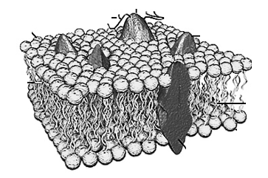
18.
19.
20.
21.
22.
23.
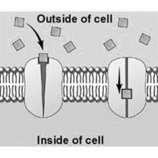

Use the picture below for question 31-37
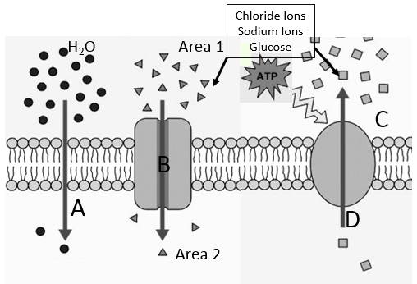
- What type of transport is represented at letters A & B above?
Passive Transport – Molecules going from areas of HIGH concentration to LOW concentration

- What type of passive transport is represented at letter A?
Simple Diffusion and Osmosis – Molecules going from HIGH concentration to LOW concentration directly through the cell membrane WITHOUT the help of a protein channel.

- What type of transport is illustrated by the arrow at letter D? Active Transport – Molecules going from LOW concentration to HIGH concentration with the help of ATP energy.

- What is diffusion? Give an example.
Molecules moving from areas of HIGH concentration to LOW concentration. Spray perfume in the corner of the room and the smelly perfume molecules will travel around the room.
- Does active transport use diffusion? NO. In Active transport, molecules go from LOW concentration to HIGH concentration. Diffusion specifically refers to molecules moving from HIGH concentration to LOW concentration.

- What is required for active transport to happen? ATP Energy!!

- As the molecules pass through protein channel B, what are they avoiding contact with?
They are avoiding contact with the hydrophobic region that is made up of lipid tails.

- An experiment was designed to test osmosis in potato cells. A student used 4 different concentrations of salt water solutions, 0%, 5%,10%, and 15%. The student measured the initial mass of the potato chunk, then let potato chunks soak in the solution for 30 minutes. Afterwards, he measured the mass of each potato chunks and recorded his results. The results are listed in the table below.
Potatoes | Solution
 | 0% salt | 5% salt | 10% salt | 15% salt
Initial Mass (grams) | 18g | 21g | 20g | 18g
Final Mass (grams) | 22g | 21g | 15g | 13g
Total change in mass (+ or - value) | +4g | 0g | -5g | -5g
Percent change in mass (%)

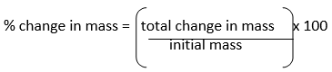

- What is the independent variable in this experiment? The concentration of salt in the solution
- What is the dependent variable in this experiment? The final mass of the potatoes
- What is the controlled variable in this experiment? The amount of TIME the potatoes were left in the solution.
- What is the % change in mass for the 15% salt solution? 27.8%

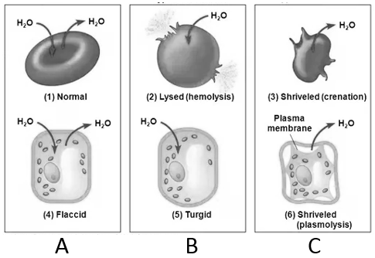
- What type of SOLUTION are each of the cells in above?
A: Isotonic (Equal percentage of solutes inside and outside the cell)
B: Hypotonic (Higher percentage of solutes inside of the cell than outside)
C: Hypertonic (Higher percentage of solutes outside of the cell than inside)
- Does water go towards or away from the greatest concentration of solute?
TOWARDS the greatest concentration of solute. If there is a greater concentration of solutes outside of the cell than inside, the water will leave the cell. This means that the SOLUTION is HYPERTONIC and the CELL is HYPOTONIC.
- The area with the greatest concentration of solute is Hypotonic or Hypertonic? HYPERTONIC

Photosynthesis & Cellular Respiration
- Write the chemical formula for photosynthesis:
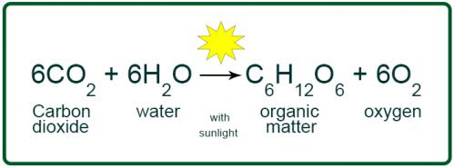

- Write the word formula for photosynthesis:

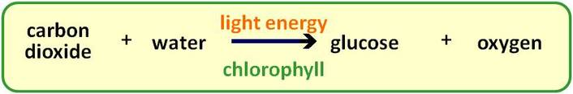
- Write the chemical formula for aerobic respiration:
- Write the word formula for aerobic respiration:

- Write the word formula for anaerobic respiration:
- What organelle allows plants to make glucose from carbon dioxide and water?
CHLOROPLASTS through the process of photosynthesis

- What organelle allows animal AND plant cells to get ATP from glucose and oxygen?
MITOCHONDRIA - Aerobic Respiration
- What are the reactants in photosynthesis?
Carbon Dioxide and Water
- What are the products of aerobic respiration?
Carbon Dioxide and Water
- What is the chemical formula for glucose?
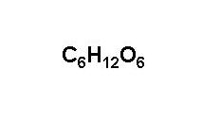
- Where is the source of all energy on earth?
The Sun
- What is anaerobic respiration?
Respiration WITHOUT oxygen
- Fermentation happens during what type of respiration?
Anaerobic Respiration
- How much ATP does aerobic respiration result in?
36 (Technically 38, but you use 2 ATP during the whole process)
- What environmental factors impact the rate of photosynthesis?
The amount of sunlight a plant receives
- What causes your muscles to be sore after you work out? What type of respiration causes that?
Lactic Acid. Anaerobic Respiration.

Macromolecule | Monomer (Building Blocks) | Purpose | Picture
Carbohydrate | Glucose | Fast Energy | 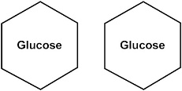
Lipid | Fatty Acids | Energy Storage  Insulation for animals  Protects Organs | 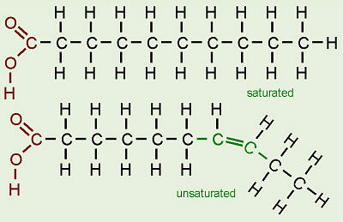
Protein | Amino Acid | Enzymes & Muscles | 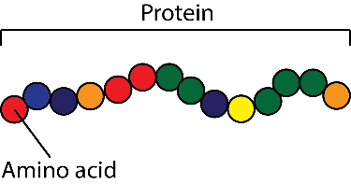  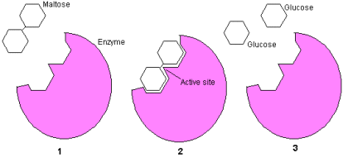
Nucleic Acid | Nucleotide | Genetic Information: DNA & RNA | 