Name:_______________________________________________Date:_______________Period:_____________
Cells & Energy Test Review
Section 1: Cell Theory & Cell Organelle Functions
- What are the 3 parts of the cell theory?
  - 1.
  - 2.
  - 3.
- What discovery led to the invention of cells? (How do we see really really small stuff?)

Describe the function of each cell part in picture below:
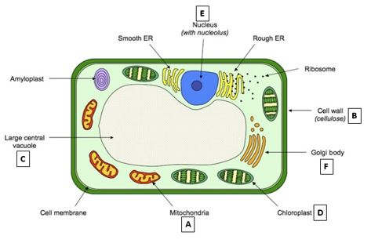
Functions:
- Nucleus:
- Vacuole:
- Ribosome:
- Golgi Body:
- Endoplasmic Reticulum:
- Chloroplast:
- Mitochondria:
- Cell Wall:
- Cell Membrane:
- Is the cell above PROKARYOTIC or EUKARYOTIC? How do you know??

- Is the cell above a PLANT cell or an ANIMAL cell? How do you know??

- Which cell parts are used for making proteins (3 organelles)?

- Which cell parts are used for producing and using energy (2 organelles)?

- Which cell part is a major factor in Cell Transport?

- What types of eukaryotic cells would contain a lot of mitochondria?

Section 2: Cell Membrane & Cell Transport
Label the following in BOTH of the pictures below
- Phospholipid Bi-Layer
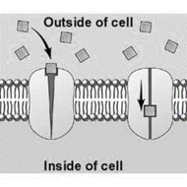
- Phosphate Head
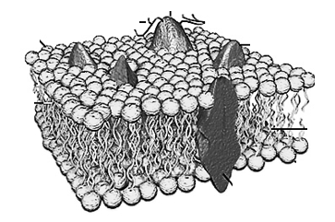
- Lipid Tail
- Hydrophobic Region
- Hydrophilic Region
- Protein Channel

Use the picture below for question 31-37
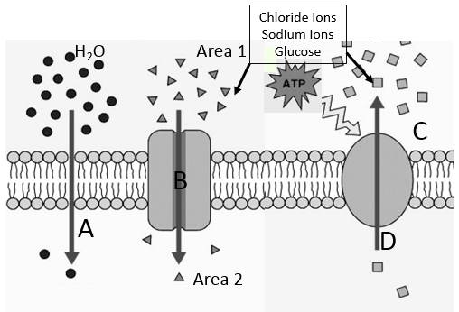
- What type of transport is represented at letters A & B above?

- What type of passive transport is represented at letter A?

- What type of transport is illustrated by the arrow at letter D?

- What is diffusion? Give an example.

- Does active transport use diffusion?

- What is required for active transport to happen?

- As the molecules pass through protein channel B, what are they avoiding contact with?

- An experiment was designed to test osmosis in potato cells. A student used 4 different concentrations of salt water solutions, 0%, 5%,10%, and 15%. The student measured the initial mass of the potato chunk, then let carrot sticks soak in the solution for 30 minutes. Afterwards, he measured the mass of each potato chunks and recorded his results. The results are listed in the table below.
Potatoes | Solution
 | 0% salt | 5% salt | 10% salt | 15% salt
Initial Mass (grams) | 18g | 21g | 20g | 18g
Final Mass (grams) | 22g | 21g | 15g | 13g
Total change in mass (+ or - value) | +4g | 0g | -5g | -5g
Percent change in mass (%)

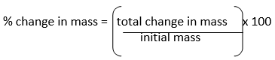

- What is the independent variable in this experiment?
- What is the dependent variable in this experiment?
- What is the controlled variable in this experiment?
- What is the % change in mass for the 15% salt solution?
Macromolecule | Monomer (Building Blocks) | Purpose | Picture
Carbohydrate

Lipid

Protein

Nucleic Acid

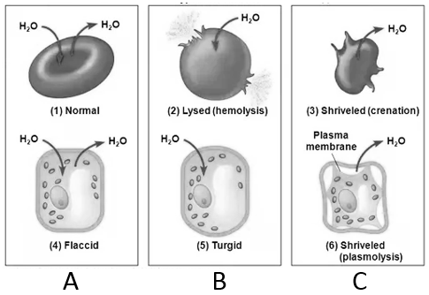
Quick Review Chart:
- What type of SOLUTION are each of the cells in above?
A:
B:
C:
- Does water go towards or away from the greatest concentration of solute?

- The area with the greatest concentration of solute is Hypotonic or Hypertonic?

Photosynthesis & Cellular Respiration
- Write the chemical formula for photosynthesis:

- Write the word formula for photosynthesis:

- Write the chemical formula for aerobic respiration:

- Write the word formula for aerobic respiration:

- Write the word formula for anaerobic respiration:

- What organelle allows plants to make glucose from carbon dioxide and water?

- What organelle allows animal AND plant cells to get ATP from glucose and oxygen?

- What are the reactants in photosynthesis?

- What are the products of aerobic respiration?

- What is the chemical formula for glucose?

- Where is the source of all energy on earth?

- What is anaerobic respiration?

- Fermentation happens during what type of respiration?

- How much ATP does aerobic respiration result in?

- What environmental factors impact the rate of photosynthesis?

- What causes your muscles to be sore after you work out? What type of respiration causes that?

