Name:______________________________________________Date:________Per:_______Pg. #_____

**Biology Agriculture Unit 5**

Evolution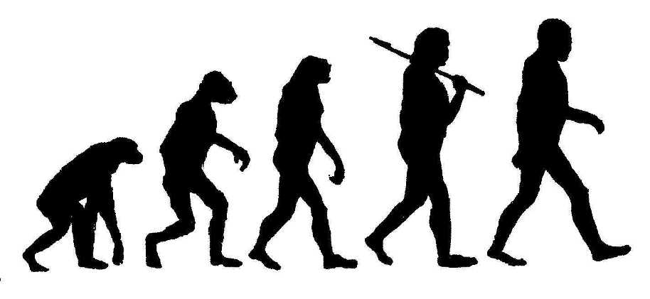

**Evolution**

Objectives:

* Relate principles of evolution to biological diversity.
  + Natural Selection
  + Artificial Selection
* Cite evidences and mechanism for changes in populations over time.
  + Homologous vs. Analogous Structures vs. Vestigial Structures
  + Divergent Evolution vs. Convergent Evolution
  + Genetic Drift, Reproductive Isolation, Geographic Isolation

Vocabulary:

Evolution:

Fossil Record:

Geologic Record:

Molecular Evidence:

Homologous Structures:

Vestigial Structures:

Variation:

Linnaean Classification Scheme

Theory:

Natural Selection:

Artificial Selection:

Adaptation:

Inference:

Speciation:

Biological Species Concept:

Biodiversity:

Taxonomy:

Dichotomous Keys:

Cladogram:

Phylogeny:

**Evolution In Action: Native U.S. Lizards Are Adapting To Escape Attacks By Fire Ants**

ScienceDaily (Jan. 24, 2009)

Penn State Assistant Professor of Biology Tracy Langkilde has shown that native fence lizards in the southeastern United States are adapting to potentially fatal invasive fire-ant attacks by developing behaviors that enable them to escape from the ants, as well as by developing longer hind legs, which can increase the effectiveness of this behavior.

"Not only does this finding provide biologists with an example of evolution in action, but it also provides wildlife managers with knowledge that they can use to develop plans for managing invasive species," said Langkilde. The results will be described in a paper to be published later this month in the journal Ecology.

Fire ants from South America, which were introduced to the United States accidentally in the 1930s, often will attack a fence lizard that has wandered onto their mound in order to protect their home. But the ants also have been observed attacking lizards that are nowhere near their mound. "Fire ants need protein, especially for their developing brood," said Langkilde. "It takes just 12 of them less than a minute to kill a three-inch-long fence lizard. In fact, they have even been known to eat animals as large as calves, stripping them down to their bones."

Langkilde conducted an experiment in which she compared the responses to fire ant attacks of lizards that were collected from four different sites: one that had not yet been invaded by fire ants and ones that were invaded by fire ants 23, 54, and 68 years ago. Her goal was to determine whether the amount of time since invasion influences the ways in which lizards respond to attacks.

To conduct the experiment, she first captured lizards from the four different sites using a little noose tied to the end of a pole. "Luckily, the lizards rely on camouflage to avoid being eaten. When they see you they lie really still, and this makes it easier to slip the noose over their heads," said Langkilde.

Next, she located a naturally occurring fire ant-mound. By dragging a stick across the top of the mound, she encouraged a few ants to come out. "We didn't want the ants to kill the lizards, so we had to be careful not to disturb the mound so much that hundreds of ants would come out," said Langkilde. "No lizards were injured during our trials."

Langkilde then encouraged the lizards to run onto the ant mound and observed their behavior as the ants crawled around on their bodies looking for scales to lift up. Once the ants have exposed a lizard's soft flesh, they will inject a neuromuscular venom into its skin that can paralyze and kill the animal.

"The lizards can survive this attack by twitching to flick off the ants and then by running away from the mound," said Langkilde. "We found that the lizards from sites that have been invaded the longest were more likely than the lizards from sites that have not yet been invaded to perform this survival behavior. Many of the lizards from the uninvaded site and the most recently invaded site just sat there with their eyes closed while the ants attacked," said Langkilde, who stopped the experiment after 60 seconds to prevent any of the lizards from dying.

To determine if hind-leg length influences the success of the twitching and running lizards in getting away from the ants, Langkilde measured the hind-leg lengths of all of the lizards. She found that, indeed, the lizards with the longest hind legs were the most successful at getting away from ants. She also discovered that lizard leg length appears to be inherited from an individual's parents. Langkilde concluded that the lizards living near fire ants are developing behaviors to increase their survival and are evolving longer hind legs in response to attacks by fire ants.

In the future, Langkilde plans to study the mechanism behind the behavioral changes following invasion. Non-responsive lizards tend to be killed and removed from the gene pool. "Non-responsive lizards are less likely to make it to reproductive age when they would be capable of passing their non-reacting, short-legged genes on to offspring," she said. Langkilde intends to investigate whether adult lizards can learn to twitch and run away from ants and whether babies that are born with the ability to survive ant attacks can lose this ability if they do not use it.

This research was supported by the Gaylord Donnelley Environmental Fellowship, the Eppley Foundation for Research, the National Geographic Society, and the American Museum of Natural History.

**Evolution in Action Article Questions**

Name ____________________________________ Period ______ **Due Date**: ________________________

Read the article focusing specifically on the methods that scientists used to gather evidence to document the evolution of species. Answer the following questions.

1. Describe what natural selection is and how it affects the process of evolution.
2. From the article, what was the animal that was experiencing natural selection?
3. What had changed in the animal’s environment that was forcing the animal to adapt in order to survive?
4. Describe the methods the scientists in the article used to study the effects of natural selection:
   1. From what specific areas were the test animals collected? Why was this important?
   2. Where did the testing on these animals take place? Why?
   3. How did the scientists test the response of the animal to the environmental changes?
   4. When being attacked, what were the 2 different ways the test animals responded to the attack?
   5. Which response would eventually be selected for and which would be selected against?
   6. Other than response to attack, what other trait helped the test animal survive?
   7. Describe, in detail, how this other trait would be selected for and against.
5. Make a guess based upon the evidence from this experiment, what 2 characteristics would the majority of this animal have in the next 10,000 years if environmental factors stayed the same.

**Notes**

______________________________________________________________________________________________________________________________________________________________________________________________________________________________________________________________________________________________________________________________________________________________________________________________________________________________________________________________________________________________________________________________________________________________________________________________________________________________________________________________________________________________________________________________________________________________________________________________________________________________________________________________________________________________________________________________________________________________________________________________________________________________________________________________________________________________________________________________________________________________________________________________________________________________________________________________________________________________________________________________________________________________________________________________________________________________________________________________________________________________________________________________________________________________________________________________________________________________________________________________________________________________________________________________________________________________________________________________________________________________________________________________________________________________________________________________________________________________________________________________________________________________________________________________________________________________________________________________________________________________________________________________________________________________________________________________________________________________________________________________________________________________________________________________________________________________________________________________________________________________________________________________________________________________________________________________________________________________________________________________________________________________________________________________________________________________________________________________________________________________________________________________________________________________________________________________________________________________________________________________________________________________________________________________________________________________________________________________________________________________________________________________________________________________________________________________________________________________________________________________________________________________________________________________________________________________________________________________________________________________________________________________________________________________________________________________________________________________________________________________________________________________________________________________________________________________________________________________________________________________________________________________________________________________________________________________________________________________________________________________________________________________________________________________________________________________________________________________________________________________________________________________________________________________________________________________________________________________________________________________________________________________________________________________________________________________________________________________________________________________________________________________________________________________________________________________________________________________________________________________________________________________________________________________________________________________________________________________________________________________________________________________________________________________________________________________________________________________________________________________________________________________________________________________________________________________________________________________________________________________________________________________________________________________________________________________________________________________________________________________________________________________________________________________________________________________________________________________________________________________________________________________________________________________________________________________________________

**Evolution Note Guide**

|  |  |  |
| --- | --- | --- |
| Key Concept | Explanation | Examples/Contributions |
| **Key People & Terms** | | |
| Evolution |  |  |
| Lamarck |  |  |
| Charles Darwin |  |  |
| Artificial Selection |  |  |
| Speciation |  |  |
| Natural Selection |  |  |
| **Types of Natural Selection** | | |
| Sexual Selection |  |  |
| Directional Selection |  |  |
| Disruptive Selection |  |  |
| Stabilizing Selection |  |  |
| **Speciation** | | |
| Convergent Evolution |  |  |
| Divergent Evolution |  |  |
| Geographic Isolation |  |  |
| Reproductive Isolation |  |  |
| **Mechanisms For Evolution** | | |
| Chromosomal fusion & recombination |  |  |
| Camouflage (adaptation) |  |  |
| Gene Flow |  |  |
| Genetic Drift |  |  |
| Mimicry (adaptation) |  |  |
| Mutation |  |  |
| **Evidences For Evolution** | | |
| Vestigial Structure (anatomy) |  |  |
| Analogous Structure (Anatomy) |  |  |
| Homologous Structure  (Anatomy) |  |  |
| Fossil Record |  |  |
| Embryology |  |  |

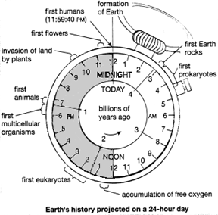**Earth’s History Projected on a 24 Hour Day… The Clock Assignment ☺**

**Name______________________________________ Period ___________________**

In this assignment you will be drawing and labeling different events in the history of the earth. You will be doing work on the 24 hour clock. You should print it off and then you will write on the clock and then turn it in with the questions that follow.

Follow the instructions.

Procedure:

1. Every hour on the 24 hour clock represents 200 Millions of years. You need to start at midnight and move counter clockwise and label the times of the earth in millions of years. Example: at 11p.m. on the clock you would write 200 MYA. At 7 p.m. you would write 1 billion years ago.
2. Now Label the following items on the clock.
   1. At 5 a.m. the very first rocks were formed on the earth
   2. At 6 a.m. the first single celled organism fossils are found
   3. At 8 a.m. the first photosynthetic bacteria are found
   4. At 1 p.m. the first Multi-Celled organisms are found
   5. At 9:18 p.m. the first shelled fish and invertebrates are found
   6. At 9:30 p.m. the first fish are found
   7. At 9:57 p.m. the first land plants appear
   8. At 10:00 p.m. the first insects on land appear
   9. At 10:06 p.m. the first amphibians appear
   10. At 10:18 p.m. the first Reptiles appear
   11. At 10:51 p.m. the first Conifers appear (trees like pines)
   12. At 10:57 p.m. the dinosaurs appear and flourish
   13. At 11:16 p.m. the first birds appear
   14. At 11:22 p.m. the first flowering plants appear
   15. At 11:30 p.m. the dinosaurs went extinct
   16. At 11:52 p.m. grasses appear
   17. At 11:59 p.m. the first early humans appear

Answer the following questions about the clock

1. What do you see on the clock about complexity of organisms with time EXPLAIN!!
2. Where do you see the most biodiversity (most organisms) on the clock and explain why!!
3. Photosynthesis appears quite early in the timeline. Before photosynthesis there was no oxygen in the atmosphere. Explain why the evolution of photosynthesis led to the appearance of animals that breathe oxygen

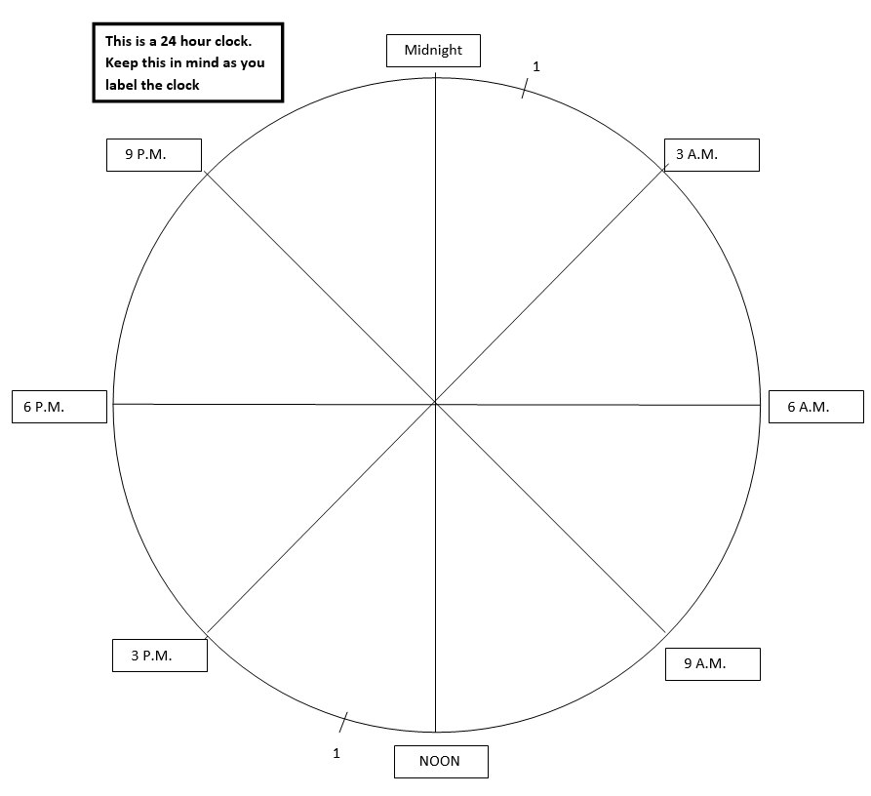

**Absolute & Relative Dating**

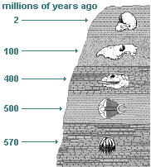

**1**. Which rock to the right above is the oldest?

2. Explain why, if you know the approximate age of the rocks above, you know the approximate age of the fossils in the rocks.

For absolute dating, we need to think back to when we talked about Atoms and Elements. Get out a book (pg. 540) and define the following terms.

**Relative Dating:**

**Radiometric Dating (absolute dating):**

Keep reading on page 540-541 and answer the following questions

4. What does radiometric dating rely on?

5. What is half-life? (Be Descriptive!)

6. How do plants get carbon-14?

7. Draw your own conclusion: How do YOU get carbon-14?

By emitting an electron and an electron antineutrino, one of the neutrons in the carbon-14 atom decays to a proton and the carbon-14 (half-life of 5700 ± 40 years) decays into the stable (non-radioactive) isotope nitrogen-14.

8. When carbon-14 decays, what does it turn into?

9. What is the half-life of Carbon-14?

10. How many years is the use of Carbon-14 limited to?

11. How long is the half life of potassium-40?

13. USE YOUR BRAIN NOW. Using the information in the question above, if you have 1000 milligrams of Carbon 14, how many milligrams of Carbon 14 will you have after one half-life?

How many milligrams of Nitrogen 14 will you now have?



STOP! Do these questions AFTER the lab:

14. Why is it important to have a big sample size?

15. What was the difference between your individual data and the class data?

Draw some Pie graphs for the questions below

16. About what percentage of original isotope/new daughter isotope will always remain after 1 half-life of any isotope?

17. About what percentage of original isotope/daughter isotope will always remain after 2 half-lives of any isotope?

**SKITTLE LAB**: In this lab, we’re going to shake and spill Skittles onto a plate. Using the information we just learned about unstable isotopes we will use skittles to represent radioactive isotopes of Carbon and newly formed unradioactive isotopes of Nitrogen. Skittles that land S - up will be considered to be RADIOACTIVE, and thus the S - down Skittles are a safe stable decay product.

YOU DO NOT WANT TO EAT RADIOACTIVE SKITTLES - SO NEVER EAT AN S- UP SKITTLE! Don’t eat any others until you know what you’re doing with them either.

Now that you know how long the half-life of Carbon is, the half lives of several radio isotopes are given in your Reference Tables.



Strontium

Argon

Lead

Nitrogen 14

5000 years

1.3 billion years

4 billion years

5730 years

PROCEDURE:

1. Get a bag of skittles and a plate to spill them out on. Assume that at one point all the Skittles were S-up on the plate. This represents a sample of 100% radioactive isotope and I’ve entered that data on the data table below.

2. Gently shake the cup of Skittles (make sure we have no flying Skittles) and gently spill them on to the plate. Carefully count and remove all the S- down Skittles, and record your results in the 2nd and 3rd columns on the table below in the 1ST Half Life row. The S - down Skittles you’ve counted are safe to eat now.

the 2nd Half Life row. The counted, recorded and removed S - down Skittles are OK to eat!

4. Do it again, recording your data in the 3rd half life row. Then do it again, and again, until all the S – up Skittles are gone.

DATA:



**Skittles with S-Down from decay of S-up Skittles**

**Cumulative number of new elements formed in column 3**

**Percent of original element (S-UP) remaining**

**Years that have Passed. Every Half Life = 600 years**

**Skittles with S-Up remaining from beginning**

**0**

**100** 

**My Three Little Pretty Graphs:**

In the first graph you will graph **original isotopes** as one line and **new daughter isotopes** as a second line. You will have two lines on this graph. Your **independent variable will be years**, and your **dependent variable will be Skittle Isotopes.** Graph 1



In your second graph you will graph the **percentage of original isotope** that remains after each half-life. Your independent variable will be Half-lifes, and your dependent variable will be percentage of original isotope.



In your third graph you will graph **CLASS DATA** with original isotopes. You will have two lines on this graph. Your independent variable will be the number of half lives, and your dependent variable will be Skittle Isotopes



Name ______________________________________________________ Period __________

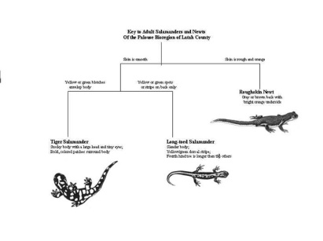**Dichotomous Keys and Cladograms**

Dichotomous keys are used as a method to determine the identity of something (like the name of an insect, plant or rock). You use a dichotomous key by going through a series of choices that lead the user to the correct name of the item. Dichotomous means “divided in two parts”.

At each step of the process of using the key, the user is given two choices; each alternative leads to another question until the item is identified (like playing 20 questions).

You are going to practice using a dichotomous key AND make one yourself! Be afraid… be very afraid (just kidding, they are easy).

First, make a dichotomous key using the materials provided by your amazing, PERFECT teacher. Remember to first separate the items into two groups, follow ONE group to completion first. When you have finished your key, holler “dear teacher of mine”…. If I can correctly identify a piece of candy using your key – the candy is yours to eat. If not…...

**My Dichotomous Key (if you need more room, grab another piece of paper from my desk):**

1a.

1b.

2a.

2b.

Now that you are done, go into the lab area. There are pictures of birds on the lab tables. You need to use dichotomous keys to identify them. Put their names below:

1 ___________________________________ 2. ___________________________________

3. ___________________________________ 4. ___________________________________

5. ___________________________________ 6. ___________________________________

Next, try classifying a few basic organisms using the field guides placed in the room. DO NOT MOVE THE FIELD GUIDES!!! THEY NEED TO STAY IN THEIR CURRENT LOCATION.

1 ___________________________________ 2. ___________________________________

3. ___________________________________ 4. ___________________________________

Cladograms: If you have trouble answering these questions, look on page 516-517 of our book.

1. What is a cladogram used for?
2. What is a common ancestor?
3. According the the cladogram below, which organisms have:
   1. Mammary glands?
   2. Claws or nails?
4. What organisms have feathers?
5. Who should have the closest DNA, Chimp and Mouse OR Pigeon and Salamander?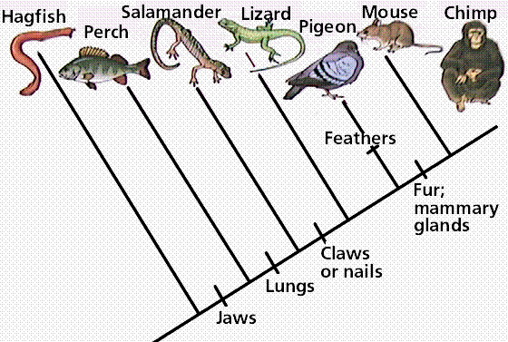

**Name_________________________________________ Period ______**

**Classification & Cladograms!**

**Introduction:** All members of the Animalia kingdom are multicellular, and all are heterotrophs (they rely on other organisms for their food). Most ingest food and digest it in an internal cavity like a stomach. Animal cells lack the rigid cell walls that plant cells have. The bodies of most animals are made up of cells, tissues and organs. Most animals are capable of complex and relatively rapid movement compared to plants and other organisms. Most reproduce sexually, by means of egg and sperm.

Somewhere around 9 or 10 million species of animals inhabit the earth; the exact number is not known and even estimates are very rough. Animals range in size from no more than a few cells to organisms weighing many tons, such as blue whales and giant squid. By far, most species of animals are insects and ants make up the majority of insects. By this measure our own group, the vertebrates, is relatively small in number.

In this activity, you will see how animals are classified and named scientifically. Many people develop a pneumonic device to remember the steps of scientific classification. Take a minute and try

it. As you work look for relationships between animals that seem alike.

|  |  |  |
| --- | --- | --- |
| **Domesticated Dog**  Kingdom: Animalia  Phylum: Chordata  Class: Mammalia  Order: Carnivora  Familiy: Canidae  Genus: Canis  Species: Canis lupus  Subspecies: C.l.familiaris | **Red Fox**  Kingdom: Animalia  Phylum: Chordata  Class: Mammalia  Order: Carnivora  Familiy: Canidae  Genus: Vulpes  Species: vulpes | **Grey Wolf**  Kingdom: Animalia  Phylum: Chordata  Class: Mammalia  Order: Carnivora  Familiy: Canidae  Genus: Canis  Species: Canis lupus |

1. Why is observation so important when classifying organisms?
2. What do we base classification groups on?
3. Scientists define a species as an interbreeding population of like organisms. Given this definition, what do you predict about the ability of dogs, wolves and foxes to interbreed?
4. Which organisms would be more closely related, the dog, fox or wolf?
5. . DNA studies have allowed scientists to know more detail about genetic similarities between organisms. What would DNA analysis of the fox, dog and wolf reveal about their DNA?

6. Looking at the data above, which organisms are most closely related?

Least?

7. A “prairie dog” is classified in order *Rodentia.* Why are common names for organisms confusing?

1. Modern classification is much different than that of 100 years ago. What does this show about the nature of scientific knowledge?

**MAKING CLADOGRAMS:**

**Concept: Modern classification is based on evolution theory**.

Background: One way to discover how groups of organisms are related to each other (phylogeny) is to compare the anatomical structures (body organs and parts) of many different organisms. Corresponding organs and other body parts that are alike in basic structure and origin are said to be homologous structures (for example, the front legs of a horse, wings of a bird, flippers of a whale, and the arms of a person are all homologous to each other). When different organisms share a large number of homologous structures, it is considered strong evidence that they are related to each other. When organisms are related to each other, it means they must have had a common ancestor at some time in the past. If there are specific modifications of those features shared by different groups of organisms, we say that those features are “shared derived characters”.

When we do studies in comparative anatomy, and find different numbers of shared derived characters exist between different groups, we can draw a diagram of branching lines which connect those groups, showing their different degrees of relationship. These diagrams look like trees and are called "phylogenetic trees" or "cladograms" (CLAY-doe-grams). The organisms are at the tips of the stems. The shared derived features of the homologous structures are shown on the cladogram by solid square boxes along the branches, and common ancestors are shown by open circles. The more derived structures two organisms share, the closer is their evolutionary relationship -- that is, the more recently their common ancestor lived. On the cladogram, close relationships are shown by a recent fork from the supporting branch. The closer the fork in the branch between two organisms, the closer is their relationship.

Step 1: DATA TABLE (This has been done for you)

Animals

|  |  |  |  |  |  |  |  |
| --- | --- | --- | --- | --- | --- | --- | --- |
| **Traits** | **Kangaroo** | **Lamprey** | **Rhesus Monkey** | **Bullfrog** | **Human** | **Snapping Turtle** | **Tuna** |
| Dorsal Nerve Cord | X | x | x | x | x | x | X |
| Paired Appendages; Spinal Column | x |  | x | x | x | x | X |
| Paired Legs | x |  | x | x | x | X |  |
| Amnion (Amniotic Sac) | x |  | x |  | x | X |  |
| Mammary Glands | x |  | x |  | x |  |  |
| Placenta |  |  | x |  | X |  |  |
| Canine Teeth Short; Forament Magnum Forward |  |  |  |  | x |  |  |
| Total # of X’s |  |  |  |  |  |  |  |

Explanations of Characteristics:

**Set #1 Dorsal nerve cord** (running along the back or "dorsal" body surface)

**Notochord** (a flexible but supporting cartilage-like rod running along the back or

"dorsal" surface)

**set #2: Paired appendages** (legs, arms, wings, fins, flippers, antennae)

**Vertebral column** ("backbone")

**set #3: Paired legs**

**set #4: Amnion** (a membrane that holds in the amniotic fluid surrounding the embryo; may or may not be inside an egg shell)

**set #5: Mammary glands** (milk-secreting glands that nourish the young)

**set #6: Placenta (**structure attached to inside of uterus of mother, and joined to the embryo by

the umbilical cord; provides nourishment and oxygen to the embryo)

**set #7: Canine teeth short** (same length as other teeth)

**Foramen magnum forward** (spinal cord opening, located forward, under skull)

Step 2: Venn Diagram:

Tuna: Backbone

Human: Foramen magnum forward

Horse: Placenta

Step 3:

Cladogram Example:

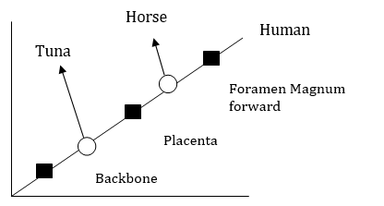

Draw your cladogram here:

1. Give two types of information which can be obtained from this cladogram:
2. Three previously unknown vertebrate have been discovered in a rain forest in South America. One animal is very similar to an iguana lizard. The second animal is resembles a large rat. The third is similar to a goldfish. Place these animals on your cladogram and explain WHY you placed them where you did.
3. Based on the reading above, what is a homologous structure?
   1. Give an example:
4. What is a shared derived characteristic?
5. According to your cladogram, who is more closely related to a Monkey? Snapping Turtle or Bull-Frog?



Use the scenario information sheets to answer the questions in each of the three sections.

**Scenario #1: Peppered Moths**

1. What effect does pollution have on the population of white peppered moths?
2. What effect does pollution have on the population of black peppered moths?
3. Describe how air pollution might be affecting the moths’ habitat (hint: look at the pictures of the moths).
4. What is your hypothesis for how the peppered moth population is changing?

**Scenario #2: E.coli**

1. If E.coli reproduce asexually, is there genetic variation in the bacteria from Day 2?
2. How could some of the bacteria have survived the antibiotic?
3. Are the bacteria that survived a whole new species from the bacteria that died? Explain your thinking.

**Scenario #3: Finches**

1. Which beak is better suited for the small seeds of West Island?
2. Which beak is better suited for the large nuts of East Island?
3. Now that you know which beaks are advantageous for each island, which type of finch would you expect to be more common on each island 50 years from now?
4. Explain your reasoning:

**Fruit Flies: Defining Speciation**

**Speciation** is an event that produces two or more separate species from one single population within a species. Imagine that you are looking at a tip of the tree of life that constitutes a species of fruit fly. Move down the **phylogeny** to where your fruit fly twig is connected to the rest of the tree. That branching point, and every other branching point on the tree, is a speciation event. At that point genetic changes etc. resulted in two separate fruit fly lineages, where previously there had just been one lineage. But why and how did it happen?

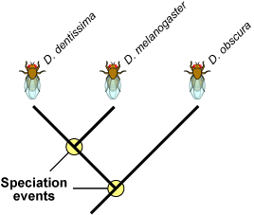The branching points on this partial *Drosophila* phylogeny represent long past speciation events that could have taken place many thousands of years ago.

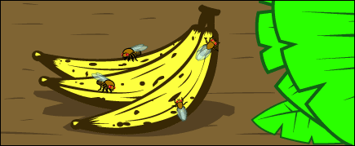Here is one scenario that exemplifies how speciation can happen:

**The scene:** a population of wild fruit flies minding its own business on several bunches of rotting bananas, cheerfully **laying their eggs** in the mushy fruit...

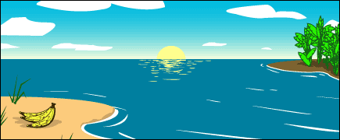**Disaster strikes:** A hurricane washes the bananas and the immature fruit flies they contain out to sea. The banana bunch eventually washes up on an island off the coast of the mainland. The fruit flies mature and emerge from their slimy nursery onto the lonely island. The two portions of the population, mainland fruit flies and island fruit flies, are now too far apart for **gene flow** to unite them. At this point, speciation has not occurred—any fruit flies that got back to the mainland could mate and produce healthy offspring with the mainland flies.

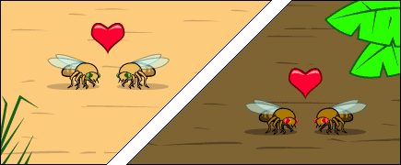**The populations diverge:** Ecological conditions are slightly different on the island, and the island population **evolves** under different **selective pressures** and experiences different random events than the mainland population does. Morphology (phenotypes), food preferences, and courtship displays change over the course of many generations of **natural selection.**

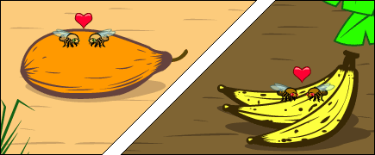**What might have caused that to happen?** Different fruits were abundant on the island. The island population was selected to specialize on a particular type of fruit and evolved a different food preference from the mainland flies. Since there were no bananas to eat and lay their eggs in they had to make use of the fruit that was available or die out!

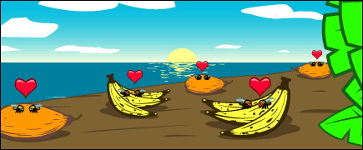Could this small difference be a barrier to **gene flow** with the mainland flies? Yes, if the flies find mates by hanging out on preferred foods, then if they return to the mainland, they will not end up mating with mainland flies because of this different food preference. Gene flow would be greatly reduced; and once gene flow between the two species is stopped or reduced, larger genetic differences between the species can accumulate.

**So we meet again:** When another storm reintroduces the island flies to the mainland, they will not readily mate with the mainland flies since they’ve evolved different courtship behaviors. The few that do mate with the mainland flies, produce inviable eggs because of other genetic differences between the two populations. The lineage has split now that genes cannot flow between the populations.

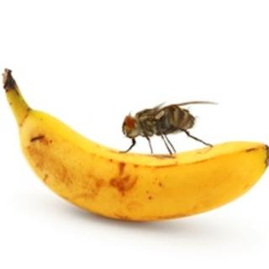**Fruit Fly Speciation Questions**

1- Read the first paragraph and look at the first picture.

a. Define Speciation from the first line.

b. Explain what the little circles mean where it says speciation event?

c. Define Phylogeny

2- Where do the fruit flies lay their Eggs and why do you think it is important to them that there is always a supply of bananas?

3- Explain what happens during the paragraph entitled: Disaster Strikes!

4-Define Gene Flow:

5- What do you think the paper means when it says that gene flow can no longer happen between the two populations?

6- Explain (2 sentences): at this point are the two populations of fruit fly (ISLAND and MAINLAND) now considered a new species because they are separated by the sea?

7- What would be some of the different selective pressures that you think the island population would face now that they are off the mainland? Hint: read the last sentence in Populations Diverge!

8- What inference does the author make about what type of selective pressures the flies might have encountered?

9- Do you think this type of selective pressure (different fruit source) could serve as the type of selective barrier that could cause lack of gene flow?

10- Explain what can happen to a population if gene flow is reduced over a long period of time. You must talk about genetic differences and mutation.

11- Now finally a storm blows some of the island fruit flies back to the mainland. What happens when some of the island flies mate with the mainland flies?

12- Would we now consider these two populations different species or would they still just be considered different populations?

Some Scientists studied Finch Beaks on the Galapogos Islands to try and prove that the finches followed natural selection the way Darwin said they would. Some of them studied the finches for one year and never noticed anything that would prove that Darwin was right. They just noticed that the finches were all eating the softer meatier fruits and they were in large supply. Thus they did not see any selective pressures that would cause competition for the food.

13- From the graph above can you infer why some of the scientists may have not seen any selective pressures that would increase beak size during their one year study?

14- Other scientists returned later and did a study that included many years of data. They saw that during years like 1984 the finches did not quarrel over food very much and that most of the finches ate the same plentiful food sources. They noticed however that during years like 1977 and 1980 the finches beaks increased in size during that year. This means that finches with bigger and stronger beaks passed their genes on better than smaller beaked finches PLEASE EXPLAIN WHY

15-Why would there be less selective pressure during a wet year???

The phylogeny below needs to be filled out by you the student.

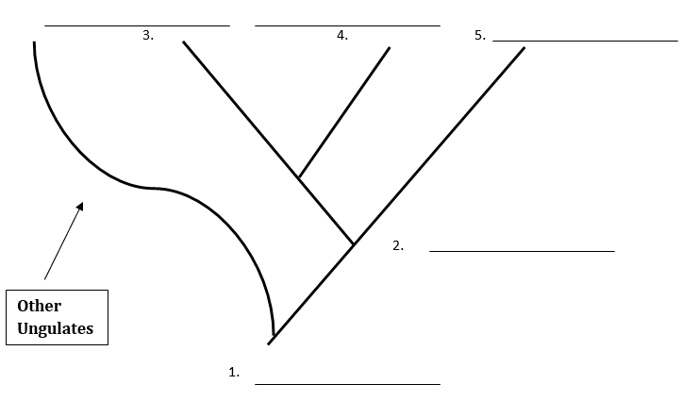

In the phylogeny above you will insert the names of the species that existed before different speciation events. Use the information that you are given below to finish the phylogeny. All underlined names will go by the numbers above.

1- An ungulate is a term given for any type of Hoofed animal. Horses split from other ungulates a very long time ago. The HYRACOTHERIUM is considered the ancestral species that existed before the Equus (horse, donkey, zebra etc.) split from other ungulates.

2. The PARISSODACTYLA is the species that existed before the modern horse linage diverged from the other equus species.

3. The MODERN HORSE has many more differences in its GENES when compared to the DONKEY and ZEBRA than the DONKEY and ZEBRA show when compared to each other.

****Butterfly Camouflage

**Beginning Question:**

What are some ways that natural selection equips organisms for survival in their environment?

**THE HIDE:**

1. Each student has 2 copies of the butterfly pattern.

3. Cut out your butterflies using the scissors at your table.

4. Your task is to pretend the classroom is a wild habitat. Look around the room and select a specific home or habitat for your individual butterflies.

5. Color each pattern with markers, crayons or colored pencils so that it will be camouflaged in the habitat you selected.

6. Also, on the back of your butterfly write your name. This will help determine who the winners are…

7. Place your butterfly in their habitat without hiding them. At least half of your butterfly must be showing! They should only be hidden by their coloring and patterns. Any butterfly that is hidden behind or beneath another object will be disqualified.

8. You will affix your butterfly to the object you choose with a single piece of tape on the back of the butterfly. You must also give at least 3 inches of clearance from anyone else’s butterfly.

9. Remember…your task is to camouflage your butterfly so that it will be difficult to see when it is sitting out in the open. You should NOT hide your butterfly behind or beneath anything.

10. You will have the rest of class today to color and hide your 3 butterflies.

**THE HUNT:**

11. Miss Baadsgaard will designate the time for the hunt to begin. They will make one complete pass around the classroom looking for butterflies. It is important for you not to give away the location of any butterfly while the “predator” is hunting. As the butterflies are found, they will be placed on the front board in plain sight.

12. Your awesome teacher will repeat this “hunt” 2 more times (a total of 3 passes) as she searches for any butterflies they missed the first time around. After the final pass, anyone who still has their butterfly out in the open will be asked to reveal the location for the class.

13. There will be a prize for the hardest butterflies to find, the ones that are still out in the open after the 3 rounds.

**Observations, Data and Questions:**

1. How many total students are in your class? _________

2. How many total butterflies were hidden during the course of this lab? ________

3. How many butterflies were found in round 1? ________

4. How many butterflies were found in round 2? ________

5. How many butterflies were found in round 3? ________

6. How many butterflies still remained out in the open at the end of round 3? ________

7. Compare and contrast the butterflies that were found first, second, third and those that weren’t found at all. What differences do you notice between the 4 groups of butterflies?

8. What are some ways that natural selection equips organisms for survival in their environment?

1. What would be the effect on the butterfly population if the coloration in the environment suddenly changed? (Example: green butterflies are living on a green plant that suddenly turns brown and loses all its leaves).

10. Most biological adaptations are specific to a certain habitat, and will not provide an advantage to an organism that moves outside this environment. What evidence have you seen in this lab that would support this idea?

**Bird Beak Adaptation**

There are three different types of birds that all have different beaks. Which type of beak do you think will survive best in their environment? Why? Which type of bird beak do you think will die off the fastest? Why?

Hypothesis:______________________________________________________________________________________________________________________________________________________________

Rule: One food item at a time! Otherwise you’ll choke to death.

Experiment 1

|  |  |  |  |
| --- | --- | --- | --- |
| Type of Beak | # Food Items | # Survived | Survival % |
|  |
|  |  |  |  |
|  |  |  |  |
|  |  |  |  |

Experiment 2

|  |  |  |  |  |
| --- | --- | --- | --- | --- |
| Type of Beak | # Food Items | | # Survived | Survival % |
|  |  |
|  |  |  |  |  |
|  |  |  |  |  |
|  |  |  |  |  |

Experiment 3

|  |  |  |  |  |  |
| --- | --- | --- | --- | --- | --- |
| Type of Beak | # Food Items | | | # Survived | Survival % |
|  |  |  |
|  |  |  |  |  |  |
|  |  |  |  |  |  |
|  |  |  |  |  |  |

**Bird Beak Activity Questions**

1. Which bird was best adapted to feeding on
   1. Beans?
   2. Straight pins?
   3. Paper pieces?
2. Which bill would be the best adapted to live in any or all of the food choices? Explain why.
3. Which bird would have the hardest time living in any or all of the food choices? Explain why.
4. Some of the pieces of paper were bent, and some were flat. Which type was most likely to be eaten?
5. What are some behavioral adaptations that these birds could use to capture more food with their bills?
6. If Jell-O were introduced as a new food source, what do you predict would happen to each population of birds?
   1. Spoonbills?
   2. Tweezerbeaks?
   3. Clothespinbills?
7. What if one of the tweezerbeaks was born with a mutation which caused its beak to be magnetic? How would this affect its food gathering and reproductive success?
8. If you were a bird, and could choose a beak type, which kind of beak would you want to be?
9. What is the difference between an animal’s survival and an animal’s fitness?
10. Explain how adaptation is involved with the process of natural selection and evolution.
11. Was your hypothesis correct or incorrect?
12. How does this activity compare with what actually occurs in nature?
13. Explain the reasoning behind doing this activity (2 full sentences).
14. What new ideas have you obtained from doing this activity (At least 1)?
15. Anything else that solidifies your learning and experience with this activity (2 sentences).

**Animal Adaptations**

**Directions:**

Look at the pictures of animals around the room. For each animal, write down a description of one of their characteristics, how it has adapted, and what purpose it’s adaptation serves.

|  |  |  |
| --- | --- | --- |
| Type of Animal | Description of identifying feature | Purpose |
|  |  |  |
|  |  |  |
|  |  |  |
|  |  |  |
|  |  |  |
|  |  |  |
|  |  |  |

**Evolution Practice Problems**

1. Poison dart frogs live in the tropical rainforests near the equator. They are very colorful. They carry a poison toxin that is deadly if ingested by other animals. Scientists have seen a rise in colorful frogs in these areas, but many of the colorful frogs are not poisonous, but just look similar to the poison dart frogs. What kind of evolutionary trend does this follow?
2. Many bird species live on the ground. This makes them extremely vulnerable to predators such as foxes and hawks. These birds usually group up in coveys. Coveys provide more senses to identify danger. This is an example of what evolutionary word?
3. Scientists have discovered two ferns that appear to look alike. The Japanese fern has the same leaf formation as the American fern. However they have different colors and spores. They determine that even though they do look alike, there is no common ancestor. This explains what evolutionary term?
4. There are many different kinds of pheasants. There is a Chinese pheasant, a golden pheasant and the ringneck pheasant. These all have different coloration and markings. However, all three kinds of pheasants can be linked to a common ancestor. What kind of evolution does this describe?
5. The iguana is a large lizard. They inhabit many locations throughout the world. Most iguanas look and behave similarly. However, the Galapagos island iguanas have evolved to swim to the bottom of the ocean in search of food. They have the name of marine iguana. The change of iguana describes what kind of selection?
6. The common ostrich only has two toes. Most other birds have three toes. A three toed ostrich is isolated in some isolated bush land. There are only fifteen other ostrich in this area when scientists first study this isolated population. When they return, scientists discover that there are now eight three toed ostriches out of the sixty counted. This shows a high frequency of the three toed gene being passed on in this population, compared to other ostrich populations. What evolutionary word best describes this example?
7. The peacock tail of the male is extremely long and colorful. Studies suggest that the tail and color are used to attract mates. Those males with long colorful tail fans are the fittest or those that will pass on their genes. Tail length and color brightness increase with time in this species. Short or medium tailed males are seen less often. What evolutionary word does this explain?
8. Beetles are scavengers. They spend most of their lives looking for food particles. Let’s suppose that a population of beetles live in a sandy area. The sand is black and white in color. Scientist do a population count and determine that there are 125 black beetles, 143 white beetles and 8 white/black speckled beetles. What kind of selection does this follow?
9. Some birds have adapted to roost in trees to avoid being eaten. Most roosting birds have medium sized wings. Having large wings makes it difficult to fly in between the branches. Having small wings makes the bird a weak flyer and more difficult to fly into a tree. Thus, most roosting birds have the medium sized wing. This explains what kind of natural selection?
10. Humans love to eat chicken. However there are many kinds of chickens. The common hen is used to lay eggs, but has scrawny thighs and breasts. Humans have bred chickens for their desired characteristics. Some chickens are meat chickens. Some are used for laying the maximum number of eggs. Some are bred for fighting. Some are bred for feather productions. This explains what evolutionary word?
11. A population of songbirds has been isolated by a 100,000 acre forest fire. They normally fly to this forest, which no longer exists, to mate. They must go to another are to mate or their genes will not be passed on because of their isolations. This explains what evoloutionary word?
12. Eagles have been known to have the same mate for their lifetimes. If their mate is killed, they may not ever find another mate. What evolutionary word explains this?
13. A small insect of one species is blown off a tree in one forest onto another tree in a different forest. This insect finds another insect of a different species to mate with. The two separate species give rise to a new species. This explains what evolutionary word?
14. Polar bears are very territorial. They travel many miles in search of food. They only live in certain areas of the world. This makes their breeding population size very small. This means they would have a small gene pool.
15. Humans walk by having their feet go in an up and down positions. Whales swim by having their tails go in the same up and down position. The bone structures in a whale’s tail fin and a human foot are very similar; however the function is completely different. One is used for swimming and the other for walking. This explains which evolutionary word?
16. Reptiles, birds, mammals, and fish embryos are very similar in the early stages of development. They later become very different organisms. This similarity in early development explains what evolutionary evidence?
17. Butterfly wings and bird wings are both used for flight. However, their wing structures are very different. What do we call this kind of evolutionary evidence?
18. While digging at a dinosaur site, you found a bone with 7.5 grams of carbon and 112.5 grams of nitrogen. How old is this bone? Use 5,730 years for one half life of carbon.

**Evolution/Geologic Time Practice Problems**

Use the following words to complete questions 1-20

­Mimicry

Analogous structures

Natural selection

Genetic drift

Disruptive selection

Reproductive isolation

Convergent evolution

Fossils

Vestigial structures

Artificial selection

Stabilizing selection

Speciation

Divergent evolution

Homologous structures

Charles Darwin

Embryology

Gene pool

Directional selection

Geographic isolation

Camouflage

**_____________________________________________________________________________________**

Read the following scenarios about evolution. Using the words above, write down the correct evolutionary word that explains each scenario.

1. Suppose there was a small population of rabbits that lived in an isolated gully in the middle of the desert. This means the rabbits only bred within their small population. One of the rabbits had longer ears which allowed it to hear approaching danger better than the other rabbits in the population. Over generations there is a high percentage that is at least one rabbit per litter will have long ears. The frequency of “long ears” is much higher in this particular isolated rabbits population than a normal large population of rabbits. What evolution word explains this high frequency of “long ears” in the isolated population?
2. Antelope live in the grassland of Africa. A population of these antelope was followed for several years. Cheetah’s and lions are the antelope’s natural predators. The antelope in the population with large legs are too strong for the cheetah’s, but slow enough for the lions to catch. The antelope with small legs are too fast for the lions, but cheetah’s can catch them easily. Having average sized legs is favored in this antelope population. What kind of selection does this represent?
3. A small population of 200 yellow beetles lived in a small pine forest. A logging company cut down a path of trees in the middle of the forest. This separated 2 male beetles from their original breeding population. These beetles now must breed with a different population of beetles or die. Which evolution word best explains the separation of the beetles from their original population?
4. A species of blue, white, and blue-white speckled butterflies live in a meadow full of blue and white wildflowers. A biologist did a butterfly count in this meadow, and found 55 blue, 60 white, and 4 speckled butterflies. This butterfly population follows which kind of selection.
5. Fox hunting is a popular sport in many countries. Dogs are used these wild K-nine foxes. Over the years people have bred dogs to have incredible olfactory or smelling noses. The dogs continue o have better noses each generation. This is an example of what?
6. A population of small fuzzy mammals lives in a rainforest in South America. The forest is extremely thick, which makes walking tough. Most of the mammals sighted have small legs, which enables them to walk under most of the thick growth. However, there are a few individuals in this population with medium and tall legs. Over generations, natural selection has favored these fuzzy mammals to have short legs. What kind of selection is this an example of?
7. Insects love to eat rose bushes, especially the tiny aphid insect. Lady bugs love to eat aphids, thus they live on rose bushes with the aphids. Most rose bushes have thorns. If you look close at those thorns you’re liable to see some thorns moving. These “moving thorns” are really aphids resembling rose bushes. What is this an example of?
8. Tigers are territorial animals. This means there are very few tigers in a given area. Poachers illegally hunt tigers for their rare fur. If poachers kill all of the female tigers in a 100-mile radius, this leaves the males with no females to breed with. These male tigers have a problem passing on their genes. In evolution, this is called what?
9. All mammals have hair or fur as a characteristic many mammals use this fur to help regulate their body temperatures. We humans are classified as mammals, thus we have hair over the surface of our bodies. Some of this hair has no known purpose, yet we still have it and pass it on from generation to generation. What kind of structure does this human body hair represent?
10. Cartilaginous fish called “rays” live in the ocean. They flap their wing like structures much like a bird flaps its wings. The difference is that rays use water against their wings, and birds use air. The structure of a bird wing and ray fin is considered as what kind of structure?
11. Preying mantis can be any color. For example, they have been seen as green, tan, white, purple and many shades of brown. Preying mantis capture their prey with raptor like front legs. They use their color to blend in with their environment. This is an example of what?
12. Archaeologist find many old life forms in rock. These ancient life forms look different than many of the present day life organisms. These strongly support the idea of change or say evolution. These ancient forms of life are known as what?
13. Birds, mammals, fish and reptiles all look similar during the first few weeks of development. This similarity supports the idea that they may have come from a common ancestor. Comparing these developing animals is called what?
14. Whale tail fins move in the same direction as lizard feet during locomotion. The structure of bone in the tail fin of a whale is surprisingly similar to the bone structure in a lizard foot. Even so, whales swim in water, and lizards walk on land. What structures are the tail of a whale and a lizard foot considered to be?
15. Brussels sprouts, cauliflower, and broccoli are related to one another. In fact, they have all come from one common ancestor. This idea that many organisms come from a common ancestor explains what kind of evolution?
16. Each year, biologists classify new species of insects throughout the tropical rainforest in the world. This is probably because of a new species arising annually. This process of a new species arising is known as what?
17. There is much evidence that supports evolution, (the gradual change of population over a long period of time). These ideas were first studied and presented by which scientist of the past?
18. Nature is considered to be cruel at times by some. Nature selects for the strongest individuals in a population to survive. Strength means being fit. Fitness in animals means having an adaptation that gives the animal an advantage over other animals in its population allowing the animal t reproduce and pass its genes on to its offspring. What word explains when nature selects which individuals survive and reproduce?
19. Genes are what makes an organism look and behave a specific way. Humans tend to have a global breeding population, while animals and plants tend to be restricted to smaller breeding populations. The genes in a given breeding population are said to be the population’s _________________________.
20. When two different species look similar to one another but have no common ancestors or recent relation, it is said to be _____________________evolution.

**_______________________­­­­­­­­­­­­­­___________________________________________________________________________**

Petrified remains

Cast

Mold

Carbonaceous film

Preserved remains

**__________________________________________________________________________________________________**

1. Living organism>dies>decays undisturbed > leaving imprint of organism.
2. Living organism > dies in ice or gooey tree spa that hardens > original remain is intact
3. Living organism > dies > living tissue and fluids decompose away > a layer of carbon is left behind portraying organism.
4. Living organism > dies > decays > leaves imprint > rock or mineral fill in imprint > a rock model of organism is made.
5. Living organism > dies > living tissue is flushed out by water and quartz > living tissue is replaced with mineral > original remains are hard, rock like.
6. Miners were digging a hole for a 1500 foot mine, and found several fossils while digging the hole. They found several bone-like fossils. They found a wooly mammoth tooth at about 800 feet down. They found a dinosaur femur bone at about 1200 feet, an ancient fern at 1400 feet, and a reptilian skeleton at 1300 feet. In addition they found a bird skull at 950 feet, a large mammal rib at 300 feet, and a mystery bone at 100 feet. There was also a large petrified tree located at 275 feet. Using your knowledge f relative dating and the principle of superposition put the names of the fossils in the correct order going from oldest to youngest.
7. The miners in the above question also encountered a small mosquito, and a moth in amber tree sap of an old tree. It was found in a fossil near the surface, thus they figured it was not older than 500,000 years old. They decided to use absolute dating to find the exact age of the mosquito and moth. Knowing that the half life of carbon-14 is 5730 years, and that the mosquito had 3.125% of carbon-14 remaining, how old is the preserved mosquito? They also found a moth that had 2.5 grams of carbon 14 and 37.5 grams of the daughter nitrogen-14. How old is the moth?